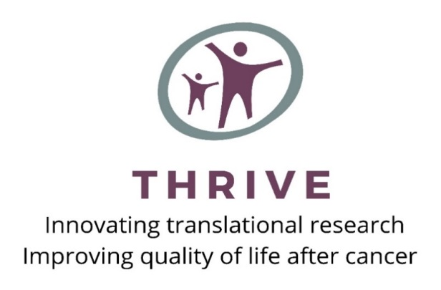
THRIVE Research Grant Application: 2021 Letter of Intent Instructions & Form

The HESI-Pardee THRIVE Grant Program has a two-step application process. A letter of intent is required in advance of submitting a full grant application. The 2021 deadline for letters of intent is 31 December 2020.

The following instructions are for investigators who are interested in being considered for THRIVE’s Research Grant Program. Only investigators who have submitted a letter of intent and have been invited by the THRIVE review board to submit a formal grant application will be considered for funding.

Letter of Intent Requirements

The letter of intent is designed to provide a general overview of the proposed research study with sufficient
detail to allow for the evaluation of the scientific merit and feasibility of the study. Two pages (letter of
intent form and research abstract) are required for submission and the remaining pages (biographical sketch
and publication list) are optional.

The letter of intent should include the following:

1. Letter of Intent Form (1 page)
The provided cover sheet should be completed and signed. Letters are to be sent to research@hesithrive.org

2. Research Abstract (1 page)
The abstract should summarize the research project and describe what issue(s) the study addresses, the study’s specific aims, relevant literature or prior research, how the study will be conducted and evaluated, and why the work will aid in the characterization or prediction of when and how adverse effects may occur in patients who have received cancer treatment and/or supports the development of approaches to avoid or lessen these effects. Preference will be given to studies in which both a non-clinical and clinical researcher are engaged in either design, conduct, or analysis of the study results.

3. Supporting Documents
The following supporting documents are optional but may be submitted with the letter of intent and
research abstract.
- Biographical sketch: This should include education and training in chronological order, positions and honors in chronological order, and past and current research support for the past three years.
- Relevant publications: This should be a short-­‐list of peer-­‐reviewed publications from the past 5 years that are relevant to the proposed research topic.

Letter of Intent Submission

A PDF copy of the letter of intent and supporting documents should be electronically submitted (email) research@hesithrive.org no later than 31 December 2020. All documents (signed letter of intent, research abstract and supporting documents) should be merged into one pdf file before sending. PDF files should be saved as “LOI_investigator first and last name_institution_2021.” An example would be to name the file “LOI_John Smith_Univ of Miami_2021.”

No extensions of the deadline can be made. Once submitted, a confirmation email will be sent to the investigator. For questions about submitting a letter of intent, please contact research@hesithrive.org.

Review and Notification Process

Each letter of intent is carefully reviewed by THRIVE’s Advisory Board to determine if the project is in line with the goals of the THRIVE award program. Preference will be given to innovative studies in which both a non-clinical and clinical researcher are engaged in either design, conduct, or analysis of the study results. Investigators will be notified by email no later than 15 February 2021 as to whether they have been approved to submit a full grant application. For eligible investigators, the submission deadline for full grant applications is 15 March 2021.

All decisions made by the THRIVE Advisory Board are final and are not subject to appeal.
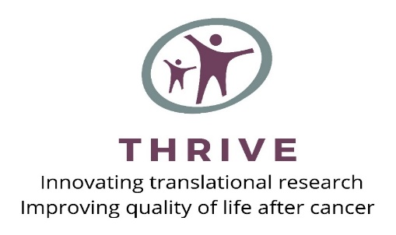
2021 Letter of Intent
THRIVE Grant Submission Form
Submit to research@hesithrive.org

RESEARCH INFORMATION

Title of Research Project:__________________________________________________________________________

Type of Research: ❏ Basic ❏ Clinical ❏ Translational
Research Involvement: ❏ Human Subjects ❏ Animal Subjects ❏ Biohazards

APPLICANT INFORMATION

Principal Investigator Name (First, MI, Last)

Title Degree(s)

Institution Division/Department

Mailing Address

Phone Fax E-­‐mail

Co-Principal Investigator (if applicable) Name (First, MI, Last)

Title Degree(s)

Institution Division/Department

Mailing Address

Phone Fax E-­‐mail

RESEARCH PROJECT BUDGET & TIMELINE/MILESTONES

Total research project budget: $

THRIVE funding requested ($50,000 maximum): $

Budget Components and Anticipated Timeline: ____________________________________________________________________________________________

____________________________________________________________________________________________

____________________________________________________________________________________________

APPLICANT’S STATEMENT

I certify that the information contained in this letter of intent submission is accurate and not misleading. I have read THRIVE’s letter of intent instructions and grant guidelines and understand THRIVE’s research grant application process.

Applicant’s Signature: ___________________________________________________

Date: _______________________

